LOCAL PLANNING POLICY – SIGNS

PURPOSE

The purpose of this policy is to establish the requirements which apply to signs and to provide guidance when determining development applications for signs.

APPLICATION OF POLICY

This policy applies to all signs on land within the Scheme area under Local Planning Scheme 3 (the Scheme) within the City of Nedlands.

Development approval under the Scheme is not required for signs located wholly on land reserved under the Metropolitan Region Scheme (MRS). An approval under the MRS may be required.

OBJECTIVES

To ensure that signs do not adversely impact on the amenity of the surrounding area.

To avoid the proliferation of signs nor signage which are not relevant to the business.

To ensure that commercial signs are generally located in non-residential areas.

To ensure that signs do not detract from the level of safety for drivers, cyclists and pedestrians.

To ensure that signage directs pedestrian and vehicular traffic appropriately and is proportionate to the scale of the building.

POLICY MEASURES

Notwithstanding any provision of this policy, an application for Development Approval is required to be obtained from the City prior to installing signage on any place which is on the City’s Heritage List or the State Heritage List.

All signs:

Shall be in keeping with the scale and form of the building;

Shall not be in any position where it obstructs the site lines of vehicles and/or pedestrians; and

Shall not contain any discriminatory or offensive material.

Shall be displayed at the site to which it relates with the exception of Sponsorship Signage cl4.4.8.

Signs exempt from requiring development approval

Street naming signs and directional signs are considered public works by a public authority on public land and are therefore exempt from requiring Development Approval.

In accordance with cl. 61(f) & cl. 61(g), Part 7, Schedule 2 of the Planning and Development (Local Planning Schemes) Regulations 2015 (the Regulations) the following signs are exempt from the requirement for development approval.

Temporary signs where in existence for less than 48 hours in any 12-month period.

Election signs where:

The advertisement is erected or installed in connection with an election, referendum or other poll conducted under the Commonwealth Electoral Act 1918, the Electoral Act 1907 or the Local Government Act 1995; and

The primary purpose of the advertisement is for political communication in relation to the election, referendum or poll; and

The advertisement is not erected or installed until the election, referendum or other poll is called and is removed no later than 48 hours after the election, referendum or other poll is conducted.

In accordance with cl. 61(h), Part 7, Schedule 2 of the Regulations the following signs are exempt from the requirement for development approval provided:

the sign satisfies the specific requirements for each sign type; and

the sign is wholly located within the boundaries of the property to which it relates and not within the road reserve.

Construction site sign
Definition | A sign that provides details or promotional material of the project, professional consultants, contractors and/or builders; displayed during construction of a building, development or subdivision. | 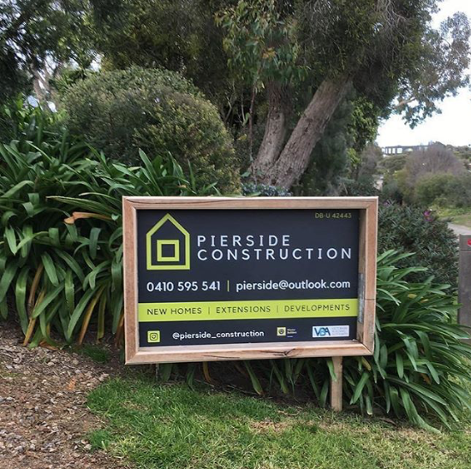₁
Development Provisions | - Shall have a maximum of one sign per street frontage;  - Shall have a maximum height of 2.0m above natural ground level;  - Shall be removed within 14 days from date of practical completion of the development; and  - Must be located wholly within the property boundary, where the development is occurring.
Permitted locations | All zones.  All reserves (except road reserves).

Name Plates and wall signs
Definition | Name Plate: A flat, usually rectangular sign which the name of a person, company etc. is printed or engraved.  Wall Sign: A sign which is affixed to the external part of a wall of the building but does not project more than 300mm from the wall and does not extend above the height or length of the wall to which it is attached. | ₂
Development Provisions | If associated with an authorised home business:  - Shall be a maximum of one sign per building; and  - Shall be a maximum of 0.2m2 in area.
Permitted locations | All zones.  All reserves (except road reserves).

Portable sign (within property boundary)
Definition | A sign which is not permanently attached to a building, structure, fence or the ground, includes ‘A-frame’ and ‘sandwich board’ signs. | ₃
Development Provisions | - Shall be located within property boundaries;  - Shall be a maximum of 1 sign per tenancy;  - Shall be a maximum of 1m in height and 1m in width;  - Do not flash or pulsate; and  - Are setback at least 1.5m from where the driveway meets the crossover.
Permitted locations | All zoned land except the Residential zone.  All reserves (except road reserves).

Property Transaction signs
Definition | A sign designed to promote the sale or lease or a property and includes the words ‘for sale’ or ‘for lease’. | ₄
Development Provisions | - Shall be a maximum of 5m2 in area;  - Does not exceed a maximum of 1 sign per street frontage; and  - Signs to adjoing the property boundary.
Permitted locations | All zones.  All reserves (except road reserves).

Statutory signs
Definition | A sign required to be exhibited by, or pursuant to, any law or policy. Includes all categories of signs. | 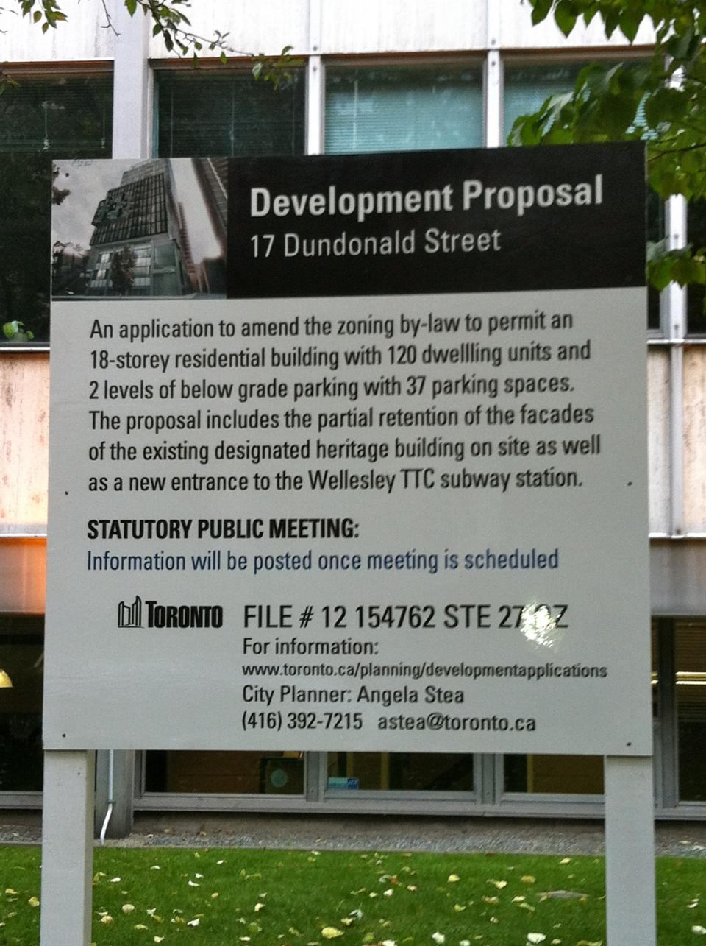₅
Development Provisions | - Shall be limited to the requirements of any applicable Act or Statute.
Permitted locations | All zones.  All reserves (except road reserves).

Window signs
Definition | A sign painted or affixed to either the interior or exterior surface of the glazed area of a window. | ₆
Development Provisions | - Does not cover more than 25% of the glazed area of the window;  - Does not exceed 10m2 in area per tenancy; and  - Does not flash or pulsate.
Permitted locations | All zoned land except the Residential zone.  All reserves (except road reserves).

Signs requiring development approval

The following signs require an application for development approval to be lodged with the City. These signs should meet the requirements as set out for the specific sign type and must be wholly located within the property boundaries to which it relates and not encroach within the road reserve.

Hoarding signs
Definition | A large freestanding advertisement, supported above ground level by one or more piers and is not attached directly to any building or other structure. | ₇
Development Provisions | - A maximum of 1 sign per site, which may be double sided;  - A maximum height of 6m above natural ground level;  - Minimum setback of 2m from adjoining sites;  - Shall be aligned at a right angle to street;  - Setback at least 1.5m from where a driveway meets the crossover; and  - Shall have a minimum clearance of 2.75m above natural ground level or where it can be demonstrated the sign complies with the requirements of the relevant Building Codes.
Permitted locations | All zoned land except the Residential zone.

Monolith signs
Definition | A sign in-filled from natural ground level to the top of the sign and appears as a solid structure when the supporting columns cannot be seen. | 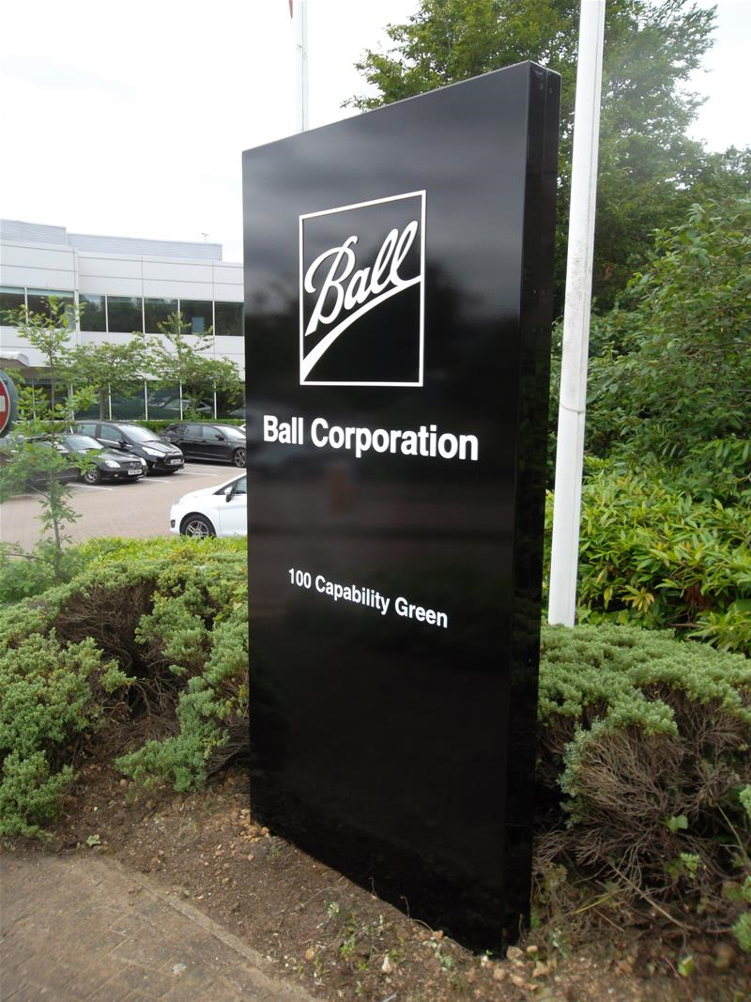₈
Development Provisions | - A maximum of 1 sign per property, which may be double sided;  - A maximum height of 6m above natural ground level and a maximum width of 2m;  - Minimum setback of 2m from adjoining sites;  - Setback at least 1.5m from where a driveway meets the crossover; and  - Shall be aligned at a right angle to street.
Permitted locations | All zoned land except the Residential zone.

Projecting signs
Definition | A sign which is attached to a projection or projects more than 300mm from a wall of the building below the eaves or ceiling height. | ₉
Development Provisions | - A maximum one sign per tenancy;  - A minimum clearance of 2.75m above natural ground level or where it can be demonstrated the sign complies with the requirements of the relevant Building Codes;  - A maximum area of 4m²;  - Signs are not to project above the height of the wall to which they are attached;  - Not to project more than 1.0m forward of the wall to which it is attached; and  - May be internally illuminated during the opening hours of the use to which it relates.
Permitted locations | All zoned land except the Residential zone.  All reserves (except road reserves).

Pylon sign
Definition | A sign supported by one or more piers and which is not attached to a building and includes a detached sign framework to which sign infills may be added. | 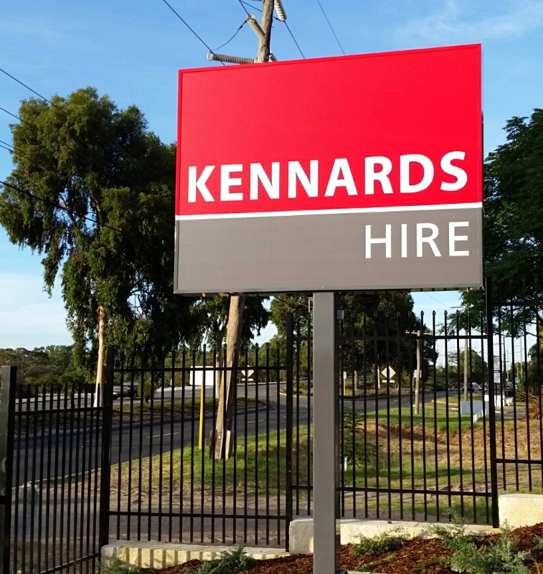₁₀
Development Provisions | - A maximum of 1 sign per site, which may be double sided;  - A maximum height of 6m above natural ground level;  - Minimum setback of 2m from adjoining sites;  - Shall be aligned at a right angle to street;  - Setback at least 1.5m from where a driveway meets the crossover; and  - Shall have a minimum clearance of 2.75m above natural ground level or where it can be demonstrated the sign complies with the requirements of the relevant Building Codes.
Permitted locations | All zoned land except the Residential zone.

Roof signs
Definition | Signs which protrude above the roof line or attached to the roof. | ₁₁
Development Provisions | - Shall have regard to the amenity of any nearby residential zoned properties;  - Shall comply with the building heights which are applicable for the property; and  - Roof signs, should not exceed a maximum area of 5m2 and a maximum height of 2m above roof level.
Permitted locations | All zoned land except the Residential zone.

Tethered signs
Definition | A sign which is suspended from or tethered to any building/structure or pole (with or without supporting framework) and made of paper, plastic, fabric or similar materials. The term includes lighter than air aerial devices, inflatables, bunting, banners, flags and kites. | ₁₂
Development Provisions | - A maximum of 1 sign per site;  - Where attached to the ground, a maximum height of 4.0m and maximum area of 5m²;  - Where attached to a pole, maximum area of 3m²;  - Tethered signs which are inflatable to be limited to one sign per lot, with a maximum height of 3.0m and width of 2m;  - To be wholly located within the property boundaries of the lot; and  - Tethered signs are not permitted to be erected on the roof of the building and project above the roofline; or where attached to a wall project above the wall height of the building.
Permitted locations | All zoned land except the Residential zone.

Sponsorship signs
Definition | A sign which is for a financial or other benefit to a sporting or community club but is not directly related to the functions or activities of the club. | 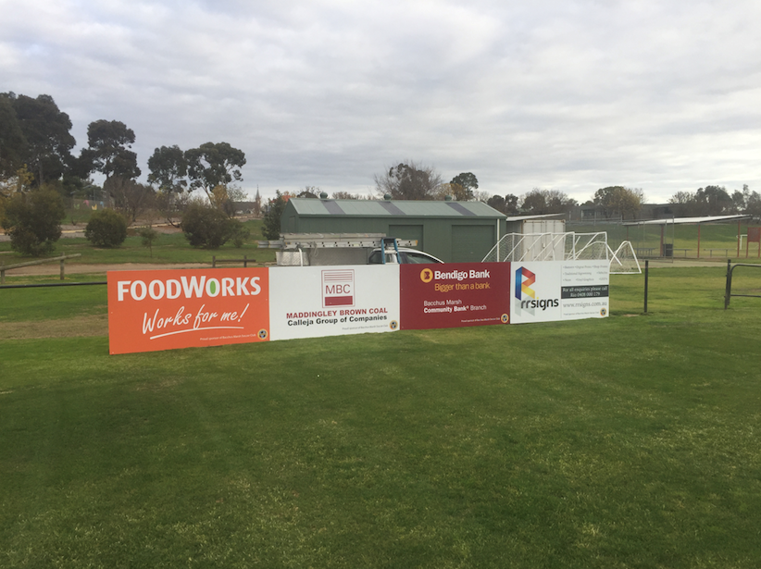₁₃
Development Provisions | - Is wholly located within the lot boundaries and adequately maintained to the satisfaction of the City;  - Shall face internally to the reserve and be setback sufficiently from lot boundaries so as not to be visually prominent from the street;  - Individual sponsorship signs shall be a maximum of 5m2 in area and up to 2.7m in height from natural ground level;  - The maximum number of sponsorship signs (fixed or moveable) shall be no greater than three signs per club. An application for a greater number of signs may be considered based on the location of signs not being visually prominent from the street; and  - Sponsorship signage which is illuminated, or flashing is not permitted.
Permitted locations | All reserves (except road reserves).

Wall signs
Definition | A sign which is affixed to the external part of a wall of the building but does not project more than 300mm from the wall and does not extend above the height or length of the wall to which it is attached. | ₁₄
Development Provisions | - Maximum two signs per tenancy;  - Maximum area of 10m² in aggregate for a tenancy;  - Must be displayed on the wall/s of tenancy in which it relates; and  - If placed directly over door openings, have a minimum clearance of 2.75m above natural ground level or where it can be demonstrated the sign complies with the requirements of the relevant Building Codes.
Permitted locations | All zoned land except the Residential zone.  All reserves (except road reserves).

Variable Message signs
Definition | Advertising signage generally affixed to a trailer and where the message can be set to change at regular intervals but does not flash or pulsate. | ₁₅
Development Provisions | - Must not obstruct vehicle, pedestrian and cycle movement;  - Not be displayed on any one lot for more than fourteen days in aggregate for any one calendar year;  - Not create visual conflict with traffic signals or roadwork signals; and  - Not be permitted where they unduly distract drives due to their display, location, content, movement or rotation, frequency or flashing, brightness or luminance.
Permitted locations | All reserves (except road reserves).

The following signs may be considered outside the boundaries of the property to which they relate and be located within the road reserve. These signs require an application for development approval to be lodged with the City and must meet the requirements as set out for the specific sign type.

Portable sign
Definition | A sign which is not permanently attached to a building, structure, fence or the ground, and include ‘A-frame’, ‘sandwich board’ and ‘garage sale’ signs. | ₃
Development Provisions | - May be considered where a building is setback less than 1m from the primary street boundary;  - Does not exceed a maximum of 1 sign per tenancy/residence;  - Does not exceed 1m in height and 1m in width;  - Are located directly outside of the property to which they relate; and  - Do not obstruct a pedestrian thoroughfare.
Permitted locations | Road Reserve

Note 1: Despite compliance with this Policy any sign in the Road Reserve may also be required to comply with the City’s Local Law Thoroughfares.

Note 2: Signs subject to any commercial agreement with the City will be required to satisfy the requirements of that commercial agreement and any policy measures set out in this Policy.

VARIATIONS TO POLICY

Variations to this policy shall be assessed against the objectives of this policy.

Applicants seeking variations to policy measures are required to submit a detailed written statement addressing each of the objectives of this policy for the City’s assessment.

Where a development application seeks to vary a policy measure, and in the opinion of the City the variation may have an adverse impact on the amenity of an adjoining property or the streetscape, the City will undertake consultation and notification of neighbouring landowners and occupiers in accordance with the City’s policy for Consultation and Notification of Planning Proposals.

ADDITIONAL DEVELOPMENT APPLICATION REQUIREMENTS

In addition to the standard Development Approval Form, as set out in the Planning and Development (Local Planning Schemes) Regulations 2015, all applications for advertisements are required to complete and submit the additional Information for Development Approval for Advertisements Form (a copy is provided as Appendix 1).

Applications for signage within the road reserve must submit a scaled dimensioned plan showing the location of the sign and minimum width for the pedestrian thoroughfare.

Applications for signage within a road reserve (including on road verges and nature strips) may require separate approval from the City under its Local Law relating to Thoroughfares.

RELATED LEGISLATION

This policy has been prepared in accordance with Schedule 2 Part 2 Clause 4 of the Planning and Development (Local Planning Schemes) Regulations 2015.

This policy should be read in conjunction with the following additional planning instruments and its requirements apply unless specifically stipulated elsewhere in any of the below:
- Planning and Development (Local Planning Schemes) Regulations 2015
- Local Planning Scheme No.3
- City of Nedlands Local Law relating to Thoroughfares
- Any relevant State or Local Planning Policies

Image References:
1. Pierside Construction - https://www.tradiepacks.com.au/products/corflute-signs
2. Fortune - http://fortune.com/2018/05/25/nordstrom-fortune-500-tech-amazon/
3. Etsy - https://www.etsy.com/nl/listing/498286389/custom-sandwich-board-sign-reclaimed
4. Economy Inn - http://economyinnlancaster.com/best-font-for-political-signs/best-font-for-political-signs-fresh-home-for-sale-signs-yard-signs/
5. Toronto Local Government - https://kitchendecor.club/files/what-process-amendments-are.html
6. Window Design Agencies - http://pin.photome.review/window-design-agencies.html
7. Award Signs - http://awardsigns.net.au/services/commercial-and-retail-signage/
8. Signs Express - https://www.signsexpress.co.uk/products-services/outdoor-business-signs/monolith-signs
9. Pics We - https://www.picswe.com/pics/projecting-signs-street-9c.html
10. Tops Images - https://www.topsimages.com/images/pylon-signage-specifications-drawings-2c.html
11. City Scoop - https://cityscoop.us/rochesterny-signs/2016/07/19/rochester-ny-searching-for-roof-signs-for-your-business-pics-included/
12. Ameramark - http://www.ameramark.com/hot_air_balloons.htm
13. Bacchus Marsh Scorpions Soccer Club - http://bacchusmarshsoccer.org.au/sponsors/
14. Boardwalk Designs - http://boardwalkdesigns.com/exterior-signs/wall/
15. Amazon - https://www.amazon.com/Message-Board-Trailer-Replacement-Solar/dp/B00K7FAQZW

Council Resolution Number | PD28.19
Adoption Date | 23 July 2019 Council Meeting
Date Reviewed/Modified

Appendix 1 –
