Section 70A Notifications
FAQ – Section 70A Notifications on Title

Section 70A is part of the Transfer of Land Act 1893 that allows notifications to be placed on a property’s Certificate of Title. This is done to ensure any current or future owners are aware of matters which may impact the enjoyment of that property and is usually applied as a condition of planning approval.

What is the process?

The flow chart below gives an overview of the process
Go to Landgate’s website to fill in the notification electronically

(Further ‘how to’ information below)

Print the form double sided and ensure all the information (including certificate of title, folio, volume and notification wording) have been filled in correctly & ensure all landowners have signed the form and it has been witnessed correctly.

Provide the original hardcopy to the City of Nedlands along with a covering letter

The Mayor and the CEO will sign – this can take up to 2 weeks to complete

The original executed document will be provided back to the applicant and be made available for collection at the City’s Offices

Lodge the document with Landgate in person or by Post. Fees apply

Provide the City a copy of the Landgate lodgement receipt to the City. This will demonstrate that the condition has been met.

How to lodge with Landgate

Below is a step-by-step guide to assist you in lodging with Landgate. However, if there are specifics questions on this process you will need to contact Landgate directly.

- Visit Landgate’s website on www.landgate.wa.gov.au

- Login or register

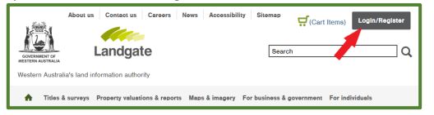

- Select E-Forms

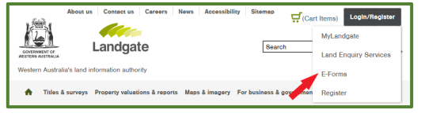

- Go to Land Titling Forms - Scroll down to Record Interest and select Notifications
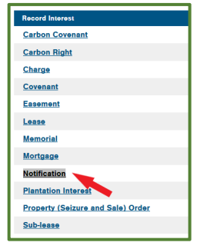

Completing the Form

- Click on the tick box

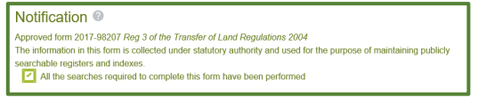

- Select Western Australia

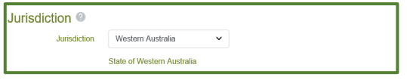

- Lodging Party Details (include your details)

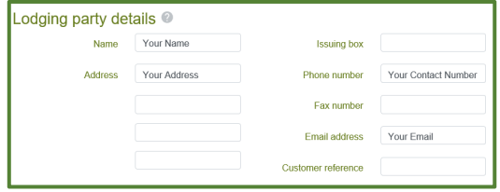

- Preparer Details (include your details)

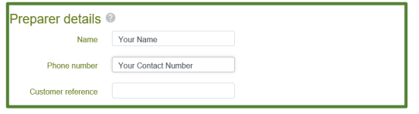

- Notification Details - to include the following (as below)

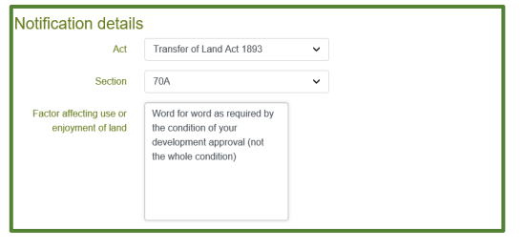
- Land Interest – Click “Add by Title”. You will need the volume and folio number from your Certificate of Title. Entered as Volume-Folio.

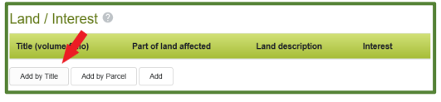

- Registered Proprietor(s) (Land) – click “Derive” and it will bring up the owner’s details

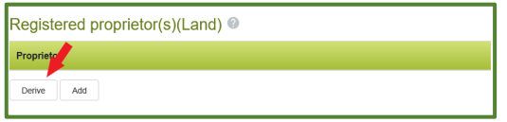

- Authorising Party – Click “Add” and include the City of Nedland’s details

- Execution Date – leave this blank

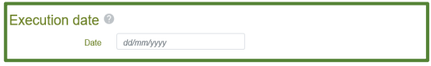
- Registered Proprietor(s) Land Execution – click “Add”

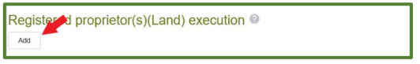

Notes: Where the land is owned by more than one person, you will need to repeat this step for each owner. Land which is owned by a person will always be “A person representing themselves”. Land owned by a company will either be “A company with a Common Seal” or “without a Common Seal”. For further information please contact Landgate directly.

- Authorising Party – Click “Add” and include the City of Nedland’s details and keep the execution type as “a blank execution block”

- Save the form & Print in colour (both sides)

- The form is signed by the proprietors and witnessed

- Send the original form to Nedland’s and refer to steps within the flow chart

How much does it cost?

Please contact Landgate directly for the lodgement fee.

Need further assistance?

If the query relates to the Landgate lodgement process you will need to contact Landgate directly on

customerservice@landgate.wa.gov.au
(08) 9273 7373
1 Midland Square, Midland
8:30am – 5pm

For all other information relating to lodgement with the City, free to contact the City’s Planning Services team:

Lodge an enquiry through the online portal on the City’s website

(08) 9273 3500
71 Stirling Highway, Nedlands (corner of Smyth Road) 8:30am – 5pm

Disclaimer This information sheet is provided as generalised information. While we aim to keep the content of this document current and accurate, we accept no responsibility or warranties for actions based on the information provided. The City encourages you to seek professional advice before acting on any information contained in this document. Please contact the City if you wish to comment on the forms provided and information contained within. Any reported errors will be amended.

