If you are landscaping and want to help protect Western Australia’s biodiversity, you may follow the below tips to create a sustainable garden/development:
SUSTAINABLE LANDSCAPING ADVICE
PLANT A NATIVE GARDEN USING LOCAL PLANTS
- Retain as much native vegetation as possible and plant local plants.
- Local plants are adapted to our local soils and climate and therefore require less water and fertilisers which protects our precious groundwater.
- Local plants provide habitat which support local wildlife such as birds and insect pollinators e.g. native bees.
- Having a garden rich in local insect pollinators provides habitat for other animals such as birds and lizards which helps to reduce pest species.
- Installing a local native garden helps conserve the diversity of the South-West biodiversity hotspot as they provide ‘stepping stones’ or ‘green corridors’.
WHAT PLANTS SHOULD I PLANT?
The City of Nedlands encourages residents to plant in accordance with their soil type. There are three soil types in Nedlands as shown on the map below:
- Cottesloe and Cottesloe Ridges
- Karrakatta
- Quindalup
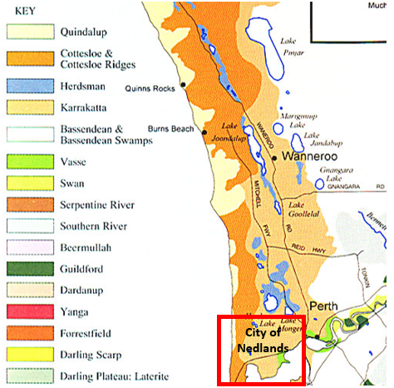
Soil Types Map from “https://www.dpaw.wa.gov.au/images/documents/conservation-management/riverpark/about/Landscape%20description%20precinct%20resource%20inventory.pdf”
:
To choose plant species according to your soil types, please refer to the below links where you will find pictures and a description of plants for your soil type:
- Cottesloe & Cottesloe ridges: Cottesloe & Cottesloe Ridges Region Archives - Apace WA
- Karrakatta: Karrakatta Region Archives - Apace WA
- Quindalup: Quindalup Region Archives - Apace WA

SMALL TREE SPECIES SUITABLE FOR URBAN AREAS
If you are unable find an appropriate local species on the above links, some smaller Western Australian native trees have been suggested in the table below. Local native plant nurseries may also be able to assist as some grow ‘dwarf’ or ‘pencil’ varieties which can be used in small or narrow areas.

Common Name | Botanical Name | Size | Origin
Bell-fruited Mallee | Eucalyptus preissiana | 3 - 5 m | WA Native
Bull Banksia | Banksia grandis | 4 – 8 m | Local Species
Coral Gum | Eucalyptus torquata | 4-11 m | WA Native
Fremantle Mallee | Eucalyptus foecunda | 4 – 5 m | WA Native
Eucalyptus forrestiana | Fuchsia Gum | 1.5-6 m | WA Native
Holly-leaved Banksia | Banksia ilicifolia | 3-8 m | WA Native
Eucalyptus 'Torwood' | Hybrid Coral Gum | 4 – 8 m | WA Native
Callistemon ‘Kings Park Special’ | Kings Park Special | 4 – 8 m | WA Native
Large Fruited Mallee | Eucalyptus youngiana | 0.8-5m | WA Native
Mottlecah | Eucalyptus macrocarpa | 4 – 8 m | WA Native
Acorn Banksia | Banksia prionotes | 3 – 8 m | Local Species
Pin-Cushion Hakea | Hakea laurina | 2.5 – 6m | WA Native
Red Flowered Mallee | Eucalyptus erythronema | 2-6 m | WA Native
River Yate | Eucalyptus macrandra | 2– 8 m | WA Native
Strickland's Gum | Eucalyptus stricklandii | 4 – 11 m | WA Native
Tallerack | Eucalyptus pleurocarpa | 4 m | WA Native
Western Tea Myrtle | Melaleuca nesophila | 2.5 - 5 m | WA Native
Webster's Mallee | Eucalyptus websteriana | 4 m | WA Native
Western Coolabah | Eucalyptus victrix | 1 - 12 m | WA Native

PROTECT VEGETATION FROM DESTRUCTIVE PLANT PATHOGENS BY:
- Using mulch that has the Australian Standard certification AS 4454 Composts, Soils Conditioners and Mulches – using AS 4454 mulch also reduces the probability of introducing weeds to your property.
- Ensuring machinery and equipment is clean before accessing the property to reduce the likelihood of bringing soil contaminated with plant pathogens.
- Using plant stock sourced from a nursery with accreditation from Nursery Industry Accreditation Scheme Australia (NIASA) – as they have the best hygiene practises.

