AGENDA

Audit Committee Meeting
Monday 1 July 2024

Notice of Meeting
To Mayor & Councillors
A Meeting of the Audit Committee of the City of Nedlands is to be held on Monday 1st July 2024 in the Council chambers at 71 Stirling Highway Nedlands commencing at 5.30pm.
This meeting will be livestreamed - Livestreaming Council & Committee Meetings » City of Nedlands
Keri Shannon | Chief Executive Officer
27 June 2024

Information

Audit Committee Meetings are run in accordance with the City of Nedlands Standing Orders Local Law. If you have any questions in relation to items on the agenda, procedural matters, public question time, addressing the Committee or attending meetings please contact the Governance Officer on 9273 3500.
Public Question Time
Public question time at an Audit Committee Meeting is available for members of the public to ask a question about items on the agenda. Questions asked by members of the public are not to be accompanied by any statement reflecting adversely upon any Council Member, Committee Member or Employee.

Questions should be submitted as early as possible via the online form available on the City’s website: Public question time | City of Nedlands

Questions may be taken on notice to allow adequate time to prepare a response and all answers will be published in the minutes of the meeting.
Addresses by Members of the Public
Members of the public wishing to address Council in relation to an item on the agenda must complete the online registration form available on the City’s website: Public Address Registration Form | City of Nedlands
The Presiding Member will determine the order of speakers to address the Council and the number of speakers is to be limited to 2 in support and 2 against any item on an Audit Committee Meeting Agenda. The Public address session will be restricted to 15 minutes unless the Council, by resolution decides otherwise.
Disclaimer
Members of the public who attend Audit Committee Meetings should not act immediately on anything they hear at the meetings, without first seeking clarification of Council’s position. For example, by reference to the confirmed Minutes of Council meeting. Members of the public are also advised to wait for written advice from the Council prior to acting on any matter that they may have before Council.
Any plans or documents in agendas and minutes may be subject to copyright. The express permission of the copyright owner must be obtained before copying any copyright material.

Table of Contents

1. Declaration of Opening 4
2. Present and Apologies and Leave of Absence (Previously Approved) 4
3. Public Question Time 4
4. Address by Members of the Public 4
5. Disclosures of Financial Interest 4
6. Disclosures of Interest Affecting Impartiality 5
7. Declaration by Members That They Have Not Given Due Consideration to Papers 5
8. Confirmation of Minutes 5
8.1. Audit Committee Meeting Minutes – 17 June 2024 5
9. Items for Discussion 6
9.1. ARC19.07.24 Update from Independent Consultant Report 7 6
9.2 ARC20.07.24 Update From Moore Australia 10
10 Date of Next Meeting 13
11 Declaration of Closure 13

Declaration of Opening

The Presiding Member will declare the meeting open at 5.30 pm and acknowledge the Whadjuk Nyoongar people, Traditional Custodians of the land on which we meet, and pay respect to Elders past, present and emerging. The Presiding Member will draw attention to the disclaimer on page 2 and advise the meeting is being livestreamed.

Present and Apologies and Leave of Absence (Previously Approved)

Leave of Absence Nil
(Previously Approved)

Apologies None as at distribution of this agenda.

Public Question Time

Public questions submitted to be read at this point.

Address by Members of the Public

Addresses by members of the public who have completed Public Address Registration Forms to be made at this point.

Disclosures of Financial Interest

The Presiding Member will remind Council Members and Staff of the requirements of Section 5.65 of the Local Government Act to disclose any interest during the meeting when the matter is discussed.

A declaration under this section requires that the nature of the interest must be disclosed. Consequently, a member who has made a declaration must not preside, participate in, or be present during any discussion or decision-making procedure relating to the matter the subject of the declaration.

However, other members may allow participation of the declarant if the member further discloses the extent of the interest. Any such declarant who wishes to participate in the meeting on the matter, shall leave the meeting, after making their declaration and request to participate, while other members consider and decide upon whether the interest is trivial or insignificant or is common to a significant number of electors or ratepayers.

Disclosures of Interest Affecting Impartiality

The Presiding Member reminded Council Members and Staff of the requirements of Council’s Code of Conduct in accordance with Section 5.103 of the Local Government Act.
Council Members and staff are required, in addition to declaring any financial interests to declare any interest that may affect their impartiality in considering a matter. This declaration does not restrict any right to participate in or be present during the decision-making procedure.

The following pro forma declaration is provided to assist in making the disclosure.

"With regard to the matter in item x ….. I disclose that I have an association with the applicant (or person seeking a decision). This association is ….. (nature of the interest).

Consequently, there may be a perception that my impartiality on the matter may be affected. I declare that I will consider this matter on its merits and vote accordingly."
The member or employee is encouraged to disclose the nature of the association.

Declaration by Members That They Have Not Given Due Consideration to Papers

Members who have not read the business papers to make declarations at this point.

Confirmation of Minutes

Audit Committee Meeting Minutes – 17 June 2024

The Minutes of the Audit Committee Meeting 17 June 2024 are to be accepted as a true and correct record of that meeting.

Items for Discussion

ARC19.07.24 Update from Independent Consultant Report 7

Meeting & Date | Audit Committee Meeting – 1 July 2024
Applicant | City of Nedlands
Employee Disclosure under section 5.70 Local Government Act 1995 | Nil.
Report Author | Craig Ross – Independent Consultant
CEO | Keri Shannon
Attachments | - Progress Report - 7  - Report 7 Appendix  - Confidential attachement (available for viewing)

Purpose

The Independent Consultant will present his report to the Audit Committee.

Recommendation

That Council receives the reports from the Independent Consultant.

Voting Requirement

Simple Majority.

Background

In addition to progress reports, the Council of the City of Nedlands requested the independent consultant to review the circumstances which led to the financial report disclaimer of opinion for the year ended 30 June 2023 with the view to enable the Council to avert such circumstances in the future.

Discussion

The seperate report identifies a number of contributing factors which led to the submission of a financial report to the Auditor without complete and accurate underlying records .
A timeline was compiled by the independent consultant which showed that the City’s executive management did not advise the Mayor or the Council of the decision by the Office of the Auditor General to provide a modified opinion, which was known to them on or about 16 November 2023.
The independent consultant has found given the significance of the decision of the Office of the Auditor General it should have been reported to the Mayor and Council immediately with a full explanation of the implications of a modified opinion. The decision by the Office of the Auditor General to provide a modified opinion, in particular a disclaimer of opinion, was not reported to the Council until late February 2024.
The independent consultant found many of the contributing factors are process and technical in nature, however they are rooted in the following key failings within the financial management processes.

The Audit Committee of the Council failed to:
- Recognise the poor quality of the financial report submitted to the auditor
- Review the financial report prior to auditor submission
- Track execution of the audit fieldwork phases and completion timelines
- Ensure key internal audit findings impacting financial reporting were addressed
- Communicate emerging audit issues to the Council in a timely manner
- Challenge executive management on finance staff turnover reasons and capacity limitations

The City’s executive management failed to:
- Keep proper accounts and records
- Manage internal control to ensure the financial report was free from material misstatement
- Report emerging audit issues in an open and timely manner to Council
- Follow better practice financial reporting and audit readiness guides
- Provide external audit progress reports to the Audit Committee
- Address appropriately the high finance staff turnover and report implications to the Audit Committee
- Monitor directly finance staff performance
- Remediate key internal audit findings impacting the financial reporting process
- Respond accordingly to the change in audit approach when information was not reasonably available

The organisational culture:
- Prevented open communication of unfavourable information
- Allowed mistrust within the hierarchical structure of the Council and the executive management team
- Did not encourage better practice financial reporting processes
- Did not address timely management of inadequate finance staff performance
The report proposes a number of financial reporting specific recommendations for immediate consideration by the Council and the Chief Executive Officer. It is probable a number of the root causes leading to the disclaimer of opinion would have evolved over a number of years. Whilst the scope of this report is limited to the financial reporting and the external audit impact, it is recommended that Council and executive management review the factors contributing to the disclaimer of opinion through an integrated approach across the organisation.

Consultation

Not applicable.

Strategic Implications

This item is strategically aligned to the City of Nedlands Council Plan 2023-33 vision and desired outcomes as follows:

Vision Sustainable and responsible for a bright future

Pillar Performance
Outcome 11. Effective leadership and governance

Budget/Financial Implications

There are no budget or financial implications in this report.

Legislative and Policy Implications

Not applicable.

Decision Implications

The Committee will be presented with a report from Mr. Ross.

Conclusion

Mr Ross will present his report to the Committee.

Further Information

Nil.

ARC20.07.24 Update From Moore Australia

Meeting & Date | Audit Committee 1 July 2024
Applicant | City of Nedlands
Employee Disclosure under section 5.70 Local Government Act 1995 | Employee disclosure required where there is an interest in any matter of which the employee is providing advice or a report.
Report Author | Michael Cole Director Corporate Services
CEO | Keri Shannon
Attachments | - Moore Australia Agenda Paper ARC Meeting 1 July 2024

Purpose

This report is for Moore Australia to present its agenda paper to the Audit
Committee.

Recommendation

That Council receives the agenda paper from Moore Australia

Voting Requirement

Simple Majority.

Background

The City’s, internal auditor Moore Australia provided this report in response to a request from the chair of the Audit & Risk Committee to summarise the status of the 320 internal audit recommendations made to the City of Nedlands since March 2020.

Discussion

While the Moore Australia progress report attached to the agenda shows the number of outstanding audit log items, the paper does not clearly indicate the age of the outstanding items.

The summary table below indicates the number of days the audit items have been outstanding:

No of days outstanding | No of outstanding items
Over 300 days | 313
Over 200 days | 9
Over 100 days | 9
The progress report from Moore Australia contained in the report is set out below:
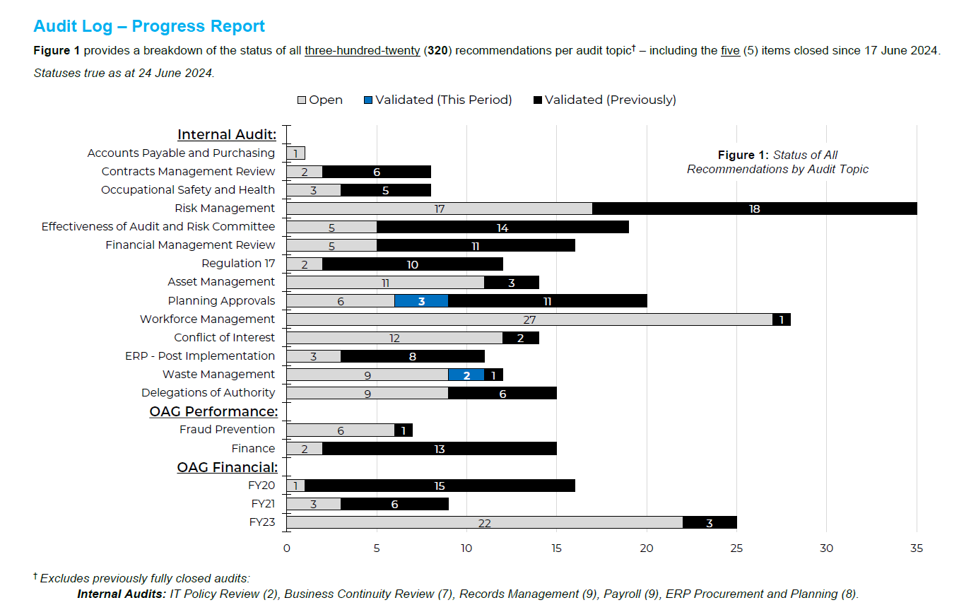

Consultation

The Presiding Member has met with the City’s Internal Auditors and agreed on future reporting timelines to the Audit Committee.

Strategic Implications

This item is strategically aligned to the City of Nedlands Council Plan 2023-33 vision and desired outcomes as follows:

Vision | Sustainable and responsible for a bright future

Pillar | Performance
Outcome | 11. Effective leadership and governance.

Budget/Financial Implications

There are no financial implication to this report.

Decision Implications

This section should highlight the implications if Council endorses the recommendation. It should also highlight the implications if Council doesn’t endorse the recommendation or pursues an alternative option.

Conclusion

It is recommended Council receives the agenda paper.

Further Information

Nil.

Date of Next Meeting

The date of the next meeting of the Audit Committee Meeting is to be 22 July 2024.

Declaration of Closure

There being no further business, the Presiding Member will declare the meeting closed.

